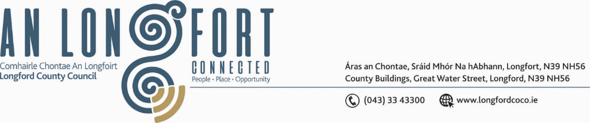

BALLYMAHON MUNICIPAL DISTRICT

Please note meeting will be held in Ballymahon Library.

21 March 2024

To: Each Member of Ballymahon Municipal District.

Dear Member,

You are requested to attend a Meeting of Ballymahon Municipal District to be held
in Ballymahon Library on Thursday 28 March 2024 at 4pm to transact business, as set out on the agenda hereunder.

Yours sincerely,

_______________
Claire McNabola,
Meetings Administrator.

AGENDA

Prayer before meeting.

- Confirmation of Minutes
- Ballymahon Municipal District Meeting held on the 22 February 2024 – enclosed.
- Ballymahon Municipal District Committee Meeting held on the 22 February 2024 – enclosed.

2. Matters arising from Minutes

3. Declaration of Interest by Members

4. Management Report – enclosed

5. Consideration of Nomination of representative to the Biodiversity Working Group

6. Consideration of Part 8 – No. 115 change of use of and renovation of existing derelict building known as Mahon’s on Main St. Edgeworthstown to a charity shop and social enterprise and all ancillary site works at the Townland of Edgeworthstown Services and associated Site works.

7. Community Grants

8. Consideration of Schedule of Ballymahon Municipal District Works – enclosed

9. Notices of Motions, submitted by Councillors, as listed hereunder –

Councillor Paul Ross
- That Longford County Council apply for an active travel scheme at the primary school in Legan up towards the N55 in front of the GAA grounds to slow traffic into the village and make it a safe area for cyclists

- That a crash barrier be installed at Quinns Bridge , Cloonbrin, Abbeyshrule on the airport side in the interest of public safety.

Councillor Mick Cahill

- That Longford County Council provide an update for the Retrofit scheme in the Ballymahon Municipal District

Councillor Pat O’ Toole
- I call on Longford County Council to provide ramps at the entrance and throughout the Creevaghbeg Estate, Mullingar Road, Ballymahon.

10. Date of Next Meeting

